Дата: 21.05.2025

Клас: 7-Б

Предмет: англійська мова

Тема: Контроль аудіювання.

Мета: : формувати навички вживання лексичних одиниць по темі; удосконалювати навички читання, аудіювання й усного монологічного мовлення; розвивати пізнавальні інтереси учнів; виховувати інтерес до самостійного пошуку потрібної інформації, а також загальну культуру учнів.

Вчитель: Руда Д.В.

Хід уроку

1.Greeting

Good afternoon, guys! I’m tickled pink to see you. Are you ready to start our lesson? All set?

Let`s get down to business.

2. Wаrm up / Listening

Уважно слухати аудіо трек і дати відповідь на питання вчителя <https://www.youtube.com/watch?v=Z00pf_uq038> .

3. Повторення

*Sleet-мокрий сніг(сліт)*

*Snowflake-сніжинка(сноуфлейк)*

*Blizzard-хуртелиця (блізард)*

*Mild: moderate in temperature; neither hot nor cold- помірний, м’який (майлд)*

*"Every cloud has a silver lining": every bad situation has some positive aspect to it. (e.g., "I lost my job, but I found a better one soon after. Every cloud has a silver lining.")- нема лиха без добра( ідіома)*

*Chilly-прохолодний(чілі)*

*To get cold-холоднішати*

*It`s raining cats and dogs-сильно дощити (ідіома)*

*precipitation-опади (прісіпітейшн)*

*partly cloudy- мінлива хмарність (патлі клауді)*

.

*To pollute-забруднювати*

*To recycle-переробляти*

*A leaflet-листівка*

*To predict-передбачати*

*A recycling bin-контейнер для сміття*

*To prevent- запобігати*

4. Speaking

|  |  |
| --- | --- |
| (1) | What do you like to do in summer that you can’t do at other times of the year? |
| (2) | Do you like summer holidays? |
| (3) | How would you feel if there wasn’t summer? |
| (4) | Do you like the summer sun? |
| (5) | Would you like it to be summer forever? |
| (6) | What’s your favourite summer memory? |
| (7) | Do you like going to summer festivals? |
| (8) | Do you think summer feels differently to people of different ages? |
| (9) | What adjectives would you use to describe summer? |
| (10) | A Swedish proverb says: "A life without love is like a year without summer." What do you think of this quote? |

5. Writing

**Контроль читання.**

**READING 7th form. Term 2**

**A Surprise Party for Gerry**

He was stuck in bed, A cute card, He was feeling rather miserable, A dozen gifts, To tease, A spectacular birthday present

**G**erry was feeling very sorry for himself. He had broken his leg, and he was in hospital. He had already been there for three weeks. Worst of all, it was his thirteenth birthday, and he didn’t want to be in hospital for that. He was stuck in bed, and it was boring, boring, boring.

**H**is birthday had started in the same way as the previous days in hospital. At half past ten the doctor came to see him. “Happy birthday, Gerry,” she said. “Can I look at your cards?” Gerry had received cards from his family and a cute one from his neighbours, but not one from his friends. Even Frankie, his best friend, had forgotten him. He was feeling rather miserable. Maybe they didn’t care about him.

**A**t lunch time his mother arrived. She had brought a dozen gifts for Gerry and soon his bed was covered in wrapping paper. His best present was a CD player. “Thanks, Mum,” he said. “That’s just what I need in here.” Things were looking up.

**S**uddenly there was a lot of noise from outside the door. Then the door flew open, and his whole class walked in. First, they sang “Happy Birthday to You” very loudly and gave him a huge card. Then they crowded round his bed and looked at all his gifts. Next, Frankie’s mother came in with a big birthday cake and paper plates. After that his classmates gave him three CDs of his favourite band. Finally, they sat around his bed and ate birthday cake.

**T**hen Gerry’s doctor came in. “We need some peace and quiet in here,” she teased. “How would you like to go home tomorrow?”

“Wow,” said Gerry. “That’s a spectacular birthday present.”

**Task 1.**  **Match.**

1. Gerry had been in hospital for a) he felt bored.

three weeks because b) his friends hadn’t sent him

2. He was stuck in bed, so anything.

3. Gerry’s family sent him cards, c) gave him a CD player.

but d) he had broken his leg.

4. His doctor came to see him that e)his friends hadn’t forgotten

morning and him after all.

5. His mother came that afternoon f) gave him some wonderful

and news.

6. His classmates had planned g) saw his cards.

surprise birthday party h) brought Gerry a card and

7. Gerry was happy because some presents.

8. Gerry’s doctor came that after-

noon and

**Task 2.**  **True or False.**

1. It was Gerry’s thirteenth birthday.

2. Gerry had received a lot of cards and gifts from his family and neighbours.

3. But Gerry wasn’t very happy.

4. Mum gave him a nice mobile phone.

5. His friends didn’t come to Gerry’s birthday.

6. The doctor said Gerry would go home tomorrow.

**Task 3. Answer the questions**.

1. Why was Gerry feeling sorry for himself?

2. How did his birthday start?

3. What did Gerry receive from his family and neighbours?

4. Why wasn’t Gerry happy?

5. Who visited Gerry then?

6. What did his classmates give him?

6. Vocabulary

*Fatigue – виснаження (фетіг)*

*Diarrhea- діарея (дайріе)*

*bite -укус*

*bleeding -кровотеча*

*bleed кровоточити*

*burn-спекти, опік*

*choking-задуха*

*choke-задушити*

*fracture-перелом*

*heart -серце*

*attack-напад*

*illness-хвороба*

*To destroy-руйнувати*

*To increase - збільшувати*

7. Homework

1. Виконати перші 10 речень (повторення article the ).

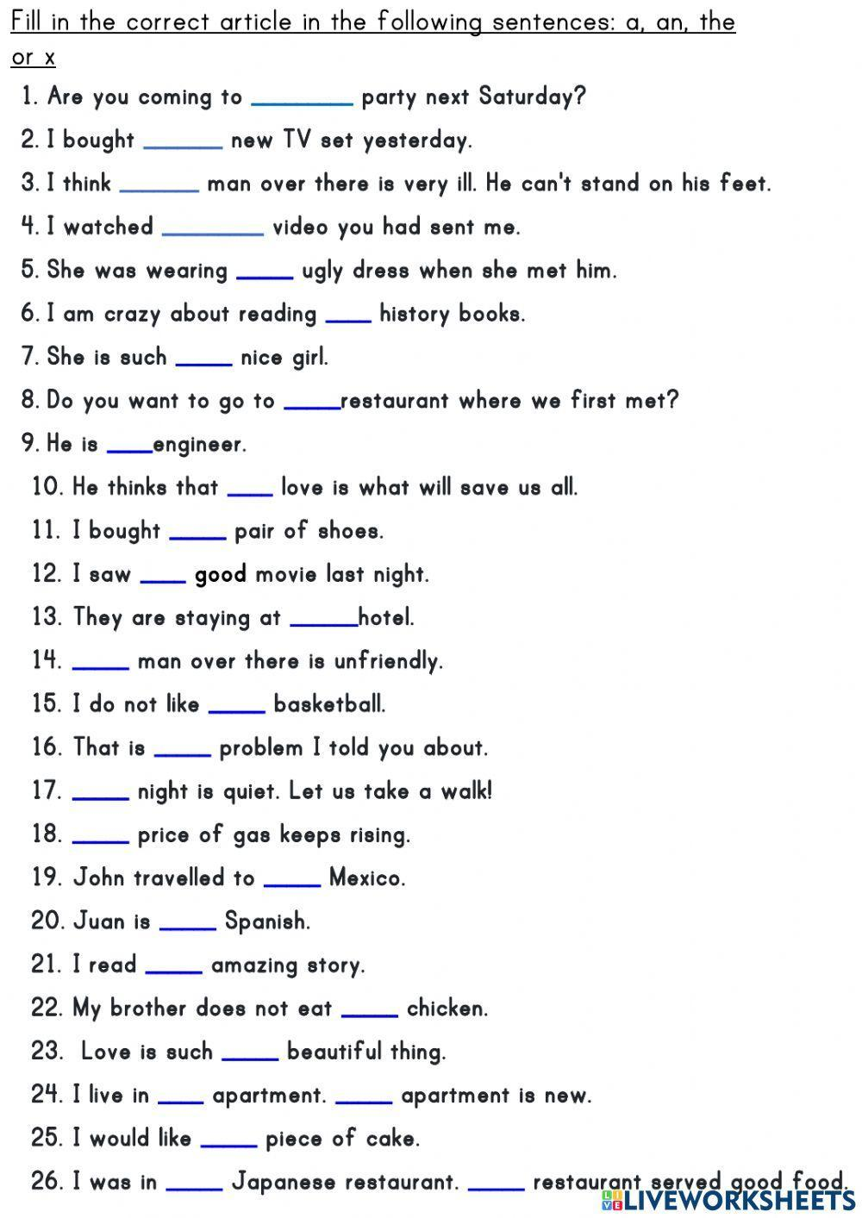

2. Повторити слова в словнику.